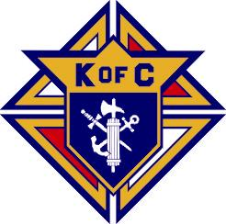
12th Annual Knights of Columbus
Holy Cross Council 5333, Kemptville

18 Hole Golf & Dinner Fundraiser

All tournament proceeds to benefit the Knights of Columbus Charities

Saturday September 9, 2017

At Nation View Golf Course

RR #1, South Mountain, ON

POWER CARTS -$15 PER PERSON - CALL JOHN at 613-258-9957 TO RESERVE

Registration at 10:00 A.M. 4 Person Scramble
Shotgun Start at 11 A.M. Sharp!
( ) I am a single golfer, please arrange for a foursome
( ) I am a member of a foursome, the golfers in my foursome are:
Golfer’s Name | Golf & Dinner  $75 | Dinner Only  $25 | Cart $15  Pay Pro Shop
Walking
Carting
Walking
Carting
Walking
Carting
Walking
Carting
Tournament is open to the first 144 registered golfers
For more information or to register by phone, please call:
John at 613-258-9957 or Jim at 613-258-7513
Make cheques payable to: K of C Council 5333
Mail entry & cheque to: John Falsetto, 13 Smith Road, Oxford Station, K0G 1T0

